 | International Civil Aviation Organization  WORKING PAPER
  ACP-WGW01/WP-04
  23/06/05

AERONAUTICAL COMMUNICATIONS PANEL (ACP)

FIRST MEETING OF THE WORKING GROUP OF THE WHOLE

Montreal, Canada 21 – 29 June 2005

Agenda Item 5: | Review of the progress on the development of new communication systems.

TECHNOLOGY PRE-SCREENING PROCESS AND EVALUATION CRITERIA

(Presented by the rapporteur of working group C)

SUMMARY
This paper reviews the methodology and progress of the technology pre-screening phase of the FAA/Eurocontrol cooperative research agreement commonly known as the Future Communications Study. NASA Glenn Research Center and ITT Industries supported the FAA, while QinetiQ supported Eurocontrol. The paper includes an overview of the technology pre-screening process, and a description of the consensus evaluation criteria. The evaluation criteria and the pre-screening process have been agreed to by ACP WG-C and are being presented under this paper for approval by the Working Group of the Whole. The detailed findings and recommendations of NASA/ITT and QinetiQ to the FAA and Eurocontrol as of the end of December 2004 are included as Appendices.
ACTION
The Working Group is requested to provide comments and approve the pre-screening process and the evaluation criteria for use in the further assessment and selection of future candidate technologies to support Air Traffic Service voice and data communications.
- INTRODUCTION
  - Action Plan 17 (AP17-04-Wp04-v1.0) outlined a research plan of joint FAA/Eurocontrol activities comprising a Future Communications Study with the objective of defining a common and globally-applicable next generation air-ground communications system. Technical Theme 3 called for the investigation of new technologies for air-ground communications. Specifically it called for the “investigation of potential communications technologies operating inside the VHF band and outside the VHF band in support of mobile communication operation concept considering terrestrial and satellite base infrastructure.” Activity Task 3.1 of AP17 outlined an activity to pre-screen potential technologies that “are under development in the industry” and to assess their “high level capabilities, projected maturity, and their potential applicability to aviation.” The timeframe for the introduction of the next generation system is 2015-20, and its objective is to meet all communications requirements projected for 2025 and well beyond.
  - In support of the FAA, NASA Glenn Research Center contracted ITT Industries to conduct the technology assessment for the pre-screening task, and Eurocontrol contracted QinetiQ for the same purpose. Close coordination between ITT and QinetiQ was maintained throughout the task, in order to reach consensus between the FAA, NASA and Eurocontrol at all critical steps in the process.
- discussion
  - The pre-screening of candidate technologies from a wide range of sources was the first phase of a multi-year, multi-phase technology assessment task conducted under Technical Theme 3. The pre-screening phase included the following activities:
- develop a process for candidate technology evaluation;
- develop a set of pre-screening evaluation criteria;
- develop a set of minimum threshold criteria that can be used to focus the effort;
- identify and characterize the candidate technologies;
- evaluate technologies and conduct sensitivity analysis; and
- provide findings and recommendations to the FAA and Eurocontrol.
  - Process for Candidate Technology Evaluation
Figure 1 below illustrates the overall process for the technology assessment task. Note that the pre-screening is the first of two phases in the process, followed by a detailed investigation phase. The purpose of the pre-screening phase is to examine a large number of potential technology candidates and recommend to the FAA and Eurocontrol a smaller subset of viable alternatives for more detailed analysis and assessment in the technology investigation phase. The down-selection to that smaller set is to be performed by the FAA and Eurocontrol, in consultation with NASA, ITT and QinetiQ. This paper documents the process for the pre-screening phase. The process used in the pre-screening is a classic trade study that is consistent with the FAA’s system engineering process.

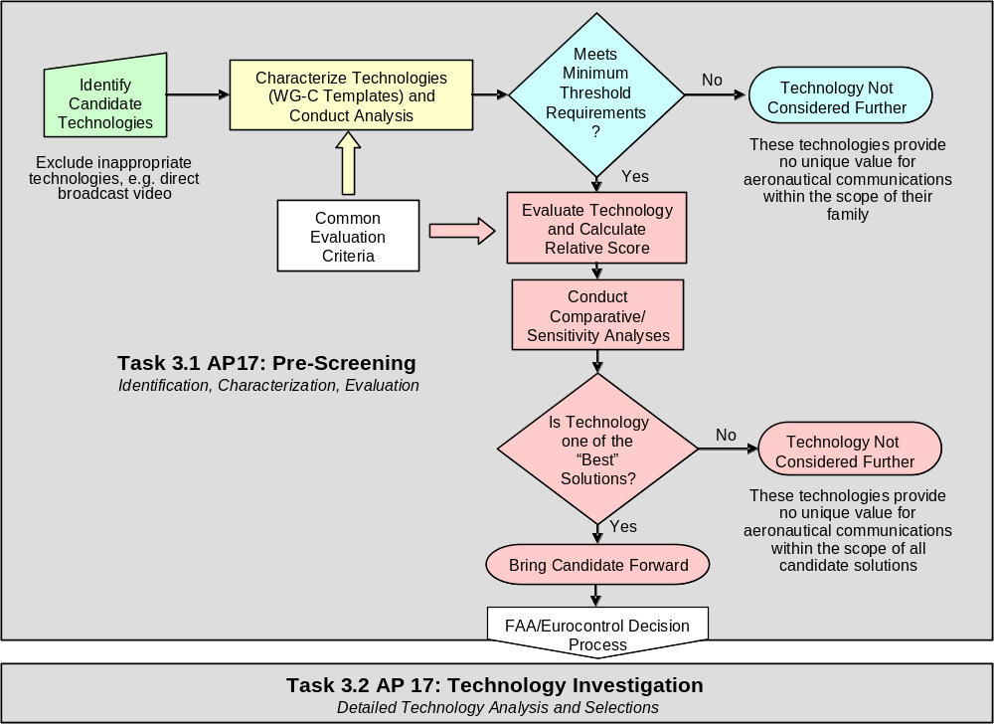
Figure 1 – Illustration of the Technology Assessment Process

  - Pre-Screening Evaluation Criteria
The technology evaluation criteria developed in the pre-screening process were driven by guiding documents from ICAO, RTCA, Eurocontrol and the FAA that address future ATM concepts and their required communications support. Table 1 below provides a list of core documentation that provided background information on future ATM concepts and associated voice and data communications services.

Document | Issuer
Global Air Navigation Plan for CNS/ATM Systems (Doc 9750) | FAA
Global ATM Operational Concept Document - AN-Conf/11-WP/4 | ICAO
ATM Strategy for the Years 2000+, 2003 Ed. | Eurocontrol
EATMP Communications Strategy, August 2003 | Eurocontrol
Operating Concept of the Mobile Aviation Communication Infrastructure Supporting ATM Beyond 2015 (MACONDO – 2002) | Eurocontrol
NAS Concept of Operations and Vision for the Future of Aviation, 2002 | RTCA
Initial Communication Operating Concept and Requirements (ICOCR) for the Future Communications System and associated references – December 2004 | FAA/Eurocontrol

Table 1 – Core Documentation

The evaluation criteria were intended to be:
- Broad enough to address a wide range of requirements and strategic objectives applicable to the future communications system;
- Suitably top-level and condensed to facilitate reaching consensus;
- Brief enough to practically apply to a large number of candidate technologies in the pre-screening phase of the overall technology assessment;
- Focused to be measurable and to discriminate among the technology alternatives; and
- Forward-looking and flexible so that the same top-level criteria used for pre-screening will be used for technology selection, but with a more precise and quantitative metrics.

The pre-screening evaluation criteria have been developed under a consensus process between the FAA and Eurocontrol that is illustrated in Figure 2.

Requirements, Technology & Transition
Analysis Team (RTTA)
Operational Concepts & Requirements Team
Technology
Assessment
Team
ICAO & Other Consensus Documents
RTTA
Evaluation
Criteria
Initial Communications Operating Concept and Requirements
ICAO & Other Consensus Documents
Final
Evaluation Criteria
Initial
Evaluation Criteria
Ground Sys Int.
Issue Papers
System Arch.
Issue Papers
Aircraft Co-Site
Issue Papers
Affordability
Issue Papers
Security
Issue Papers
Safety – Cert.
Issue Papers

Figure 2 – Evaluation Criteria Development Process

Key events in the timeline for the evaluation criteria development process were:
- July 2004 – ITT synthesized evaluation criteria from 11th ICAO Air Navigation Conference (September/October 2003) recommendations.
- August 2004 – ITT and QinetiQ worked towards refining the evaluation criteria, and developing a consensus set of criteria. In parallel, the FAA’s Requirements, Technology and Transition Analysis (RTTA) team proposed a set of evaluation criteria based on identified critical issues.
- September 2004 – ITT and QinetiQ consensus criteria were mapped to the independently developed RTTA criteria and presented to NASA and the FAA. The mapping showed substantial overlaps and highlighted missing criteria in the ITT and QinetiQ set, which were adopted. The evaluation criteria were base-lined, and the FAA RTTA team began the work of defining evaluation metrics.
- October 2004 – Through two rounds of FAA comments, ITT and QinetiQ replies, and then a round table discussion between ITT, NASA and the FAA RTTA team, evaluation metrics were decided and harmonized. In the process, some of the evaluation criteria were modified. An additional criteria, transition is adopted, and one criteria, “commercial-off-the-shelf” (COTS) Leveraging (criteria 9), was eliminated. The evaluation criteria and metrics were placed under configuration control on October 7, 2004.

The chosen evaluation criteria illustrated in Table 2 below reflect a broad range of technical and strategic objectives that are traceable to the conditions for a new aeronautical communications system that were articulated at the 11th ICAO Air Navigation Conference. The first three categories covering communications capabilities, maturity and cost (criteria 1 through 8) are in direct alignment with the guidance that a new system should provide communication capabilities that support current and emerging ICAO ATM concepts; be technically proven and consistent with the requirements for safety; and be cost-beneficial. The fourth category incorporates other important criteria such as the availability of protected (Route) spectrum, security and accommodation of transition.

Category | Evaluation Category Description | Item # | Criteria
Communications Capabilities | Communication capabilities needed to support current and emerging ICAO ATM concepts | 1 | Meets Voice Needs
Communications Capabilities |  | 2 | Meets Basic Datalink Needs
Communications Capabilities |  | 3 | Meets Expanded Datalink Needs
Maturity for Aeronautical Environment | Technical maturity as well as the recognition for the safety assurance required for aeronautical standardization and certification | 4 | Technology Readiness Level
Maturity for Aeronautical Environment |  | 5 | Standardization
Maturity for Aeronautical Environment |  | 6 | Certification
Cost | Cost of infrastructure used by the service provider as well as the cost of avionics equipage by aircraft | 7 | A/G Communications Infrastructure
Cost |  | 8 | Avionics
Other | Availability of suitable AM(R)S spectrum, support for security, and practical accommodation of transition | 10 | Spectrum Protection
Other |  | 11 | Security
Other |  | 12 | Transition

Table 2 – High Level Pre-Screening Evaluation Criteria
Note that each evaluation category is broken down into multiple criteria. Additionally, the criteria within the category of communications capabilities are complex. As will be described below, they incorporate multiple sub-criteria that specifically address functional, capacity, and performance capabilities. A technology candidate is evaluated against each criterion or sub-criterion in accord with a metric that grades it as Green, Yellow, or Red, with Green representing the best rating. The high-level criteria for assessing the communications capabilities of the candidate technologies were broken down into finer sub-criteria as described in Table 3 below.

1 – Meets Voice Needs
A. Functional Capabilities: Supported Voice Services | 1. Pilot-Controller Talk Group: this is essentially the setup and maintenance of a group conference call between a Controller and all of the Pilots in the domain of that Controller.
A. Functional Capabilities: Supported Voice Services | 2. Pilot-Controller Selective Addressing: supports a call and dialog between a Controller and a selected Pilot that is not overheard by other Pilots
A. Functional Capabilities: Supported Voice Services | 3. Direct Pilot-Pilot: the candidate allows Pilots to talk directly with each other without requiring other facilities as an intermediary.
A. Functional Capabilities: Supported Voice Services | 4. Broadcast capability. The technology provides a voice broadcast capability.
B. Capacity Capabilities | 1. Capacity provided: The candidate supports a significant increase in communications capacity.
B. Capacity Capabilities | 2. [Item Deleted]
B. Capacity Capabilities | 3. Address space. The candidate supports a sufficient number of addressed users per talk group.
C. Performance Capabilities for Pilot Controller Voice Services | 1. Aircraft mobility management: should dynamically manage Talk Groups as aircraft members join and leave. The intent of this is that a candidate can add or subtract users without denial of service (to remaining talk group members) and without unacceptable additional controller/pilot workload.
 | 2. Latency: The candidate should have acceptable one-way end-to-end voice latency
2 – Meets Basic Datalink Needs
A. Functional Capabilities: Supported Data Services | 1. Air-to-Ground and Ground-to-Air Addressed Data Transport
A. Functional Capabilities: Supported Data Services | 2. Ground-to-Air Broadcast Data Transport
B. Capacity Capabilities | 1. Aggregate Data Rate: This criterion assesses the data throughput provided to a user group. The bit rates are aggregate and include all transmitted bits. The assessment is whether the aggregate data rate to and from aircraft in a user group is acceptable. Should a distinction between average and peak be required (technology specific detail) then the analyst annotation should explain what is being evaluated and why.
B. Capacity Capabilities | 2. Number of Users: The number of users that can receive addressed data services in a user group is acceptable.
C. Performance Capabilities for Data Transport | 1. Uplink and Downlink Priority Levels / QoS: service supports priority levels such that traffic at a lower priority does not degrade higher priority traffic beyond its required QoS.
C. Performance Capabilities for Data Transport | 2. Latency: Be consistent with the end-to-end latency requirements by classes of traffic as specified for ICAO Annex 10, Volume III, Part 1, Chapter 3 covering the ATN
3 – Meets Expanded Datalink Needs
A. Functional Capabilities: Expanded Data | 1. ADS-B: The candidate’s capability to support ADS-B services.
A. Functional Capabilities: Expanded Data | 2. Pilot-Pilot Data Transport: The candidate allows Pilots to exchange data with each other. It is not necessary that this function be provided as a direct avionics-to-avionics transport. An intermediary is acceptable when provisioning this service.
B. Capacity Capabilities | 1. Aggregate Data Rate: This criterion assesses the data throughput provided to a user group. The bit rates are aggregate and include all transmitted bits. The assessment is whether the aggregate data rate to and from aircraft in a user group is acceptable. Should a distinction between average and peak be required (technology specific detail) then the analyst annotation should explain what is being evaluated and why.

Table 3 – Evaluation Criteria for Communications Capabilities

The criteria for assessing the technical maturity, cost and other attributes of the candidate technologies are described in Table 4 below. Further descriptions of the evaluation criteria are included in Appendix 1 to this paper.

4 – Technology Readiness Level | Assigned based on assessment of the Technology Readiness Level of the proposed candidate.
5 – Standardization Status | Assigned based upon the existence of applicable standards for the candidate.
6 – Certifiability | Assigned based on measure of certification risk.
7 – Ground Infrastructure Cost | Assigned based on relative cost to replace or upgrade infrastructure with the necessary availability and diversity requirements for critical services, as a replacement to VHF DSB-AM; where applicable, replacement of a ground station covering a large area (e.g., high enroute sector) should be assessed: thus, a candidate not able to project a signal at a large range from a single ground station would require multiple replacement ground stations; this naturally penalizes candidates that cannot practically project a signal at a large range. The evaluation will include any unusual maintenance requirements of a candidate (to include leased services, maintenance of Network Operational Centers, extraordinary Telco bandwidth requirements and the like).
8 – Cost to Aircraft | Assigned based on relative cost to upgrade avionics with new candidate voice and data link technology but maintain VHF DSB-AM capability.
9 – COTS Leveraging | [Item Deleted]
10 – Spectrum Protection | Assigned based upon the extent to which the potential frequency bands are consistent with aeronautical safety critical communications.
11 – Security | Assigned based upon the extent to which candidate supports authentication and integrity. Status is assigned based upon the extent to which candidate supports authentication and integrity (A&I).
12 – Transition | Assigned based on acceptable transition characteristics, including: return on partial investment; ease of technical migration (spectral, physical); and ease of operational migration (air and ground users).

Table 4 – Evaluation Criteria for Technical Maturity, Cost and Other Factors
- ACTION BY THE MEETING
  - The ACP Working Group of the Whole is invited to note the technology pre-screening process and evaluation criteria as per Figures 1 and 2 and Tables 2 through 4. The Working Group is requested to provide comments and approve the pre-screening process and the evaluation criteria for use in the further assessment and selection of future candidate technologies to support Air Traffic Service voice and data communications.
- END -

